Proof

This is a module aimed at students who are nearing the end of the year 10 course and preparing for higher level mathematics. The intention is to develop an understanding of what exactly is a mathematical proof and build some skills in writing proofs, as well as some knowledge in the language and notation of proofs.

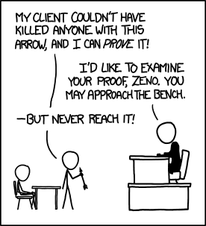

Proof Lesson 0: Notation

Before you launch into anything it will be useful to have a reference of some of the symbols used and what they mean. Create a page in your workbook titled **Notation** and add the following:

|  |  |
| --- | --- |
| $A=\{1,5,π\}$ | Curly brackets denote a **set**; here is the set *A* with three **elements**, the numbers 1, 5 and $π$ |
| $∈$ and $∉$ | **Belongs to** (is an element of) and does **not belo­­­ng to** (is not an element of) a set. In the example above, 5∈A but 6∉A |
| $$B=\{x:x≥4\}$$ | The colon, : , represents **given** or **such that**. So *B* is the set of all $x$  **such that** the $x$ 's are equal to or greater than 4. |
| $N=\{0,1,2,3,...\}$ | The set of **Natural Numbers**. Sometimes does not include 0 (which can be written as $N^{+}$ ) |
| $$Z=\{...,-2,-1,0,1,2,...\}$$ | The set of **Integers**. We also write Z+ for {1,2,3,...} |
| $Q$ | The set of **Rational Numbers**: numbers that can be written as a fraction $\frac{a}{b}$  where $a,b∈Z$ |
| $R$ | The set of **Real Numbers**(all numbers that we can place on the usual number line) |
| $$R∖Q$$ | The set of real numbers with the rational numbers removed. This is the set of **Irrational Numbers**. |
| ∴ | **Therefor** |
| $$∀$$ | **For all** |
| $$∃$$ | **There exists** |
| $$⟹$$ | **Implies**. We would write $A⟹B$  to mean that **if***A* is true **then** *B* must be true also |
| iff or $⟺$ | **If and only if** (iff) and double implication (⟺) do the same thing. A⟺B means that A and B are true whenever the other is true, or *if and only if* the other one is true. |

# Proof Lesson 1: Proof by Counter Example

Watch the following (it should stop at the 17 minute mark) and make notes of everything that the lecturer writes. Then attempt the questions at the end.

(In the video the lecturer draws his $N$ 's differently to the standard Australian way)

<https://www.youtube.com/embed/L3LMbpZIKhQ?rel=0&amp;start=20&amp;end=1020>

**Problem Set 1**

The lecturer gives two examples of proving a proposition is false by giving a **Counter Example**.

Prove that the following propositions are false by giving a counter example:

1. If it is a Monday then it rains in Bowral

2.

3.

4.

5. Can you use proof by counter example to prove that a proposition is True?

And for a challenge:

6. Describe which sets of numbers make the predicates in questions 2 - 4 **True**.

# Proof Lesson 2: Implication, Propositions and Direct Proof

Again, take notes on everything the lecturer writes down, then copy the example below and answer the questions below.

**Proving an Implication (by Deduction)**

To prove that A ⟹ B we construct the proof as follows

(note the indenting - this is not necessary but helpful, it's good to think about why):

----------------------------------------------------------------------------

Assume A to true

      Do some careful **deductive** steps. This is the same as doing valid steps in solving an equation.

      Reach the **conclusion** that B is true

State that A ⟹ B

----------------------------------------------------------------------------

Example

Prove that $∀n∈N,n>1⟹\frac{1}{n}<1$

Proof

Let $n∈N$  with $n>1$

$n>1$

$\frac{n}{n}>\frac{1}{n}$         (inequality doesn't change direction as $n>0$ )

$1>\frac{1}{n}$

$\frac{1}{n}<1$

. $∴n>1⟹\frac{1}{n}<1$

It should not look like this:

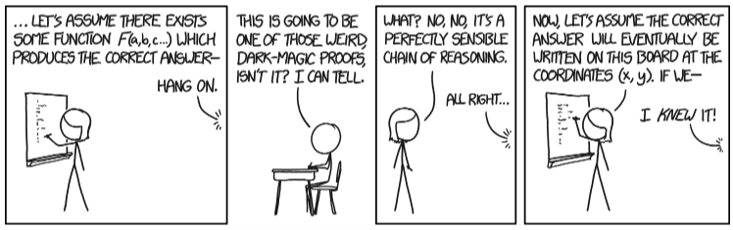

**Problem Set 2**

1. Is the proposition "if it rains, then I get wet", true?

2. Construct an implication that is true, but whose parts are both false

3. Prove that $∀n∈Z,n≥2⟹n^{2}≥4$ by sketching a graph and writing an argument

For a challenge:

4. Prove that $∀a∈R$ , ${\left(a-1\right)}^{2}≥1 →\frac{a^{2}}{2}≥a$

# Proof Lesson 3: Structure and setting out

**What should a proof look like?**

The final written proof should follow the following structure:

1. State what you are trying to prove

2. State what you have been given

3. Finish with what you are trying to prove

4. In between 3 and 4, there should be a series of sentences (remember an equation is a type of sentence), that follow clearly from one another. Each new sentence should be **truth preserving**(you should discuss what that means with someone).

Now the word clearly is the most difficult part - in a proof this means that each new sentence can only be created using things that we already know to be true. These could facts such as $n^{2}≥0$  or logical steps, such as adding the same number to both sides of an equation.

**How do I start a proof?**

Sometimes it is hard to know where to begin, but the following is an excellent summary (full videos [here (Links to an external site.)Links to an external site.](https://www.youtube.com/watch?v=VrAwuszhzTw&t=184s)):

STEP 1: Write down what we have been given

STEP 2: Write down the definition of each technical term in what we have been given

STEP 3: Write down what we are required to prove

STEP 4: Write down the definition of each technical term in what we are required to prove

STEP 5: THINK*

* Some time may be spent on this step

Remember, if you are stuck, think of some problem solving strategies that might help:

* List examples, organise. Throw in some numbers and see if you can spot a pattern
* Draw a diagram
* Look at the end (what you are required to prove)

**Problem Set 3**

1. Prove that the angle sum of a triangle is 180 degrees.

2. Prove that if $m,n∈Z$  and that $m,n$  are even, then $m+n$  is even also.

Hint: If $m$  *is even then we can write*

3. Prove that if  are odd, then  is even.

4. Prove that

5. Prove that

6. Prove that $∀a,b∈R,a^{2}+b^{2}≥2ab$

Hint: You can use the fact that for any $c∈R,c^{2}≥0$

Challenge:

7. If Q4 and Q5 are changed so that the supposition is just $a>b$  instead of $a>b>0$  , does the result still stand? Can you demonstrate why / why not?

# Proof Lesson 4: Proof by Contradiction

In an earlier problem set we proved that $a^{2}+b^{2}≥2ab$  for $a,b∈R$ . You probably used a method that was an example of a **Direct Proof**, such as the following:

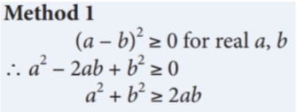

Another way of proving this is to use **Proof by Contradiction**. This works like:

1. Suppose that the opposite of thing you are require to prove is True (i.e. that what you are trying to prove is False)

2. Make careful deductive steps until you reach a statement that you know is False (this is the **contradiction**).

3. You can then deduce that the error was in step 1, your supposition, and you can then deduce that what you are trying to prove is True, because otherwise it leads to a **contradiction**.

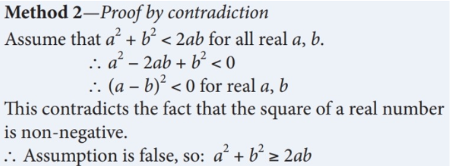

**A famous example - Infinitely Many Primes**

Watch and enjoy:

[Infinite Primes - Numberphile (Links to an external site.)Links to an external site.](https://www.youtube.com/watch?v=ctC33JAV4FI)[](https://www.youtube.com/watch?v=ctC33JAV4FI)

**Problem Set 4**

1. Prove that if

2. Prove that for

3. Prove that there are infinitely many natural numbers

Challenge:

4. Attempt any (or all) of 1 - 3 by using a Direct Proof method

5. Can you form a geometric understanding of the result of Q2? You might consider squaring both sides or picturing the results on a number line.

# Proof: Lesson 5 - Axioms

Watch the following, but no need to take extensive notes. You should take down the definition of an Axiom. Then complete the (slightly absurd) questions below.

<https://www.youtube.com/embed/L3LMbpZIKhQ?rel=0&amp;start=2137>

**Problem Set 5**

1. Prove that  (note that this is a double implication, you will need to prove both directions)

Challenge

2. Do you think it is better for a system of Axioms to be Complete or Consistent (knowing you can't have both, thanks Gödel!)? Explain why you made your choice.

# Proof: Further Reading

A great resource, but much more comprehensive and technical (some of the questions were taken from here): [https://www.birmingham.ac.uk/Documents/college-eps/college/stem/Student-Summer-Education-Internships/Proof-and-Reasoning.pdf (Links to an external site.)Links to an external site.](https://www.birmingham.ac.uk/Documents/college-eps/college/stem/Student-Summer-Education-Internships/Proof-and-Reasoning.pdf) or [herePreview the document](https://oxley.instructure.com/courses/957/files/85393/download?wrap=1)

Highlights:

* Page 15 has some "Bad Proofs"
* Page 17 has some examples of Proof by Cases or Proof by Exhaustion (different names for the same thing)
* Page 31 has some good tips and common pitfalls
* Video links! There are links in the document to videos on some of the methods

# Proof: Solutions

**Problem Set 1**

1. If it is a Monday then it rains in Bowral

*On Monday 3rd December it did not rain in Bowral.*

2. $∀a,b∈R,{ \left(a+b\right)}^{2}=a^{2}+b^{2}$

*If $a=1$ and $b=2$ then ${\left(a+b\right)}^{2}={\left(1+2\right)}^{2}=9$ and $a^{2}+b^{2}=1^{2}+2^{2}=5$, hence ${\left(a+b\right)}^{2}≠a^{2}+b^{2}$ for all $a,b∈R$*

3. $∀a,b∈R, \sqrt{a+b}=\sqrt{a}+\sqrt{b}$

*If $a=1$ and $b=4$ then $\sqrt{a+b}=\sqrt{1+4}=\sqrt{5}$ and $\sqrt{a}+\sqrt{b}=\sqrt{1}+\sqrt{4}=1+2=3$, hence $\sqrt{a+b}≠\sqrt{a}+\sqrt{b}$ for all $a,b∈R$*

4. $∀a∈ R, 1÷\frac{1}{a}=a$

*If $a=0$ then $1÷\frac{1}{a}=1÷\frac{1}{0}$ which is undefined, however the RHS (Right Hand Side) is equal to 0, hence*

5. Can you use proof by counter example to prove that a proposition is True?

*Not really, a counter-example is always used to so that a statement for all things is false. However, you can you a counter example to show that a proposition saying that ‘not all’ things of some type are true.*

6. Describe which sets of numbers make the predicates in questions 2 - 4 **True**.

*For 2 and 3 it is true whenever a or b is 0, with the additional condition for 3 that they are also non-negative. For 4 it is just all the real numbers* except *for 0.*

**Problem Set 2**

1. Is the proposition "if it rains, then I get wet", true?

*No, as you could be inside.*

2. Construct an implication that is true, but whose parts are both false.

*If then .*

3. Prove that $∀n∈Z,n≥2⟹n^{2}≥4$ by sketching a graph and writing an argument

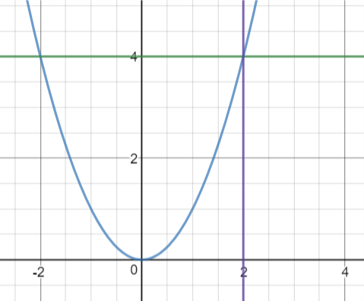

*From the graph we can see that beyond the point n=2 on the horizontal axis the graph of n2 is always above the line for y = 4*

4. Prove that ,

**Problem Set 3**

1. Prove that the angle sum of a triangle is 180 degrees.

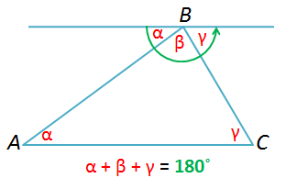*Draw a line parallel to one side of the triangle and through the opposite vertex ( $β$ on the diagram). Then the other angles in the triangle are equal to angles on the straight line as shown (using alternate angles in parallel lines). Then the sum of the angles is the same as the sum of the angles in a straight line, 180 degrees*

2. Prove that if $m,n∈Z$  and that $m,n$  are even, then $m+n$  is even also.

If m and n are even then we can write $m=2a$ and $n=2b$ where $a$ and $b$ are integers. Then $m+n=2a+2b=2(a+b)$ which is even.

3. Prove that if $m,n$  are odd, then $m+n$  is even.

*If m and n are odd then we can write $m=2a+1$ and $n=2b+1$ where $a$*  and $b$ are integers. Then $m+n=2a+1+2b+1=2a+2b+1 =2(a+b+1)$ which is even.

4. Prove that $∀a,b∈R,a>b>0⟹\frac{1}{b}>\frac{1}{a}$

*If both a and b are positive, then ab is positive also.*

$$a>b \\ \frac{a}{ab}>\frac{b}{ab} \\ \frac{1}{b}>\frac{1}{a}$$

*Note that we need to know that ab is positive in order to keep the direction of the inequality in step 2.*

5. Prove that $∀a,b∈R,a>b>0⟹a^{2}>b^{2}$

. $a>ba^{2}>ab$ (multiplying the first line by $a$) $ab>b^{2}$ (multiplying the first line by $b$) $a^{2}>ab>b^{2}$ (combining the previous two lines)

.

6. Prove that

7. If Q4 and Q5 are changed so that the supposition is just $a>b$  instead of $a>b>0$  , does the result still stand? Can you demonstrate why / why not?

*Q4 only works if $ab>0$, so it is true if* ***both*** *a and b are negative, but not in general. Q5 produces a different result if either a or b is negative, and the inequality can even be turned into an equality. For instance if $a = -4$ and $b = 4$, then $a>b$ but $a^{2}=b^{2}$*

**Problem Set 4**

1. Prove that if $a∈R^{+},a+\frac{1}{a}≥2$

Suppose that $a+\frac{1}{a}<2$ and that $a>0$

Then $a^{2}+1<2a$

and, $a^{2}-2a+1<0$ which means that ${\left(a-1\right)}^{2}<0$, but this cannot be true as a squared number cannot be negative, so the original assumption is contradicted, therefore

2. Prove that for $a,b∈R^{+},\frac{a+b}{2}≥\sqrt{ab}$

Assume that $\frac{a+b}{2}<\sqrt{ab}$, for $a,b>0$. As they are both positive we can square both sides and preserve the inequality (Q5 from the previous exercise). Therefore:

$${\left(\frac{a+b}{2}\right)}^{2}<{\left(\sqrt{ab}\right)}^{2} \\ \frac{a^{2}+2ab+b^{2}}{4}<ab \\ a^{2}+2ab+b^{2}<4ab \\ a^{2}-2ab+b^{2}<0 \\ {\left(a-b\right)}^{2}<0$$

Which cannot be true as a squared number cannot be negative, so the original assumption is contradicted, hence

3. Prove that there are infinitely many natural numbers.

*Assume that there is not infinitely many natural numbers. Then there must exist some largest number, $m$. But $m + 1 > m$, which contradicts our assumption, so there must be infinitely many natural numbers.*

4. Attempt any (or all) of 1 - 3 by using a Direct Proof method

$${\left(a-1\right)}^{2}≥0 \\ a^{2}-2a+1≥0 \\ a^{2}+1≥2a \\ a+\frac{1}{a}≥2$$

Q2 is done in a similar ‘reverse’ fashion to the proof by contradiction. Q3 is very hard (impossible?) to do directly.

5. Can you form a geometric understanding of the result of Q2? You might consider squaring both sides or picturing the results on a number line.

**Problem Set 5**

1. Prove that $∀n∈N,n=n+1⟺0=1$  (note that this is a double implication, you will need to prove both directions)

*First we show that $n=n+1→0=1$*

$$n=n+1 \\ 0=0+1 \\ 0=1$$

*Then we show that*

*Hence,*

2. Do you think it is better for a system of Axioms to be Complete or Consistent (knowing you can't have both, thanks Gödel!)? Explain why you made your choice.

*There is no right answer to this, but the mathematical consensus is to go for consistency over completeness.*